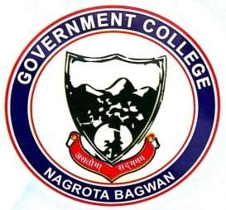
GOVERNMENT COLLEGE
NAGROTA BAGWAN
Distt. Kangra (H.P.)-176047
Tel.: 01892-251177
EMAILID: gcnagrotabagwan@gmail.com

This is to certify that no case of student ragging and sexual harassment has been reported in the session 2022-23.

